MLPG_solution in Matlab
Run the MLPG_solution function, which implements modules 5., 6. and 8. If everything ok, several figures should be plotted. For example, for diffusion on a domain with hole intPX=18, time=5, etc., we get position of discretization nodes, Initial values, solution in nodes, and evaluated solution on a mesh:
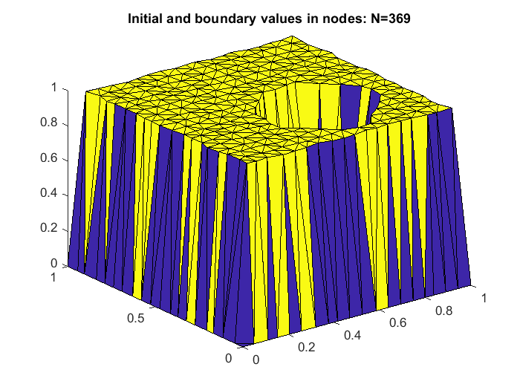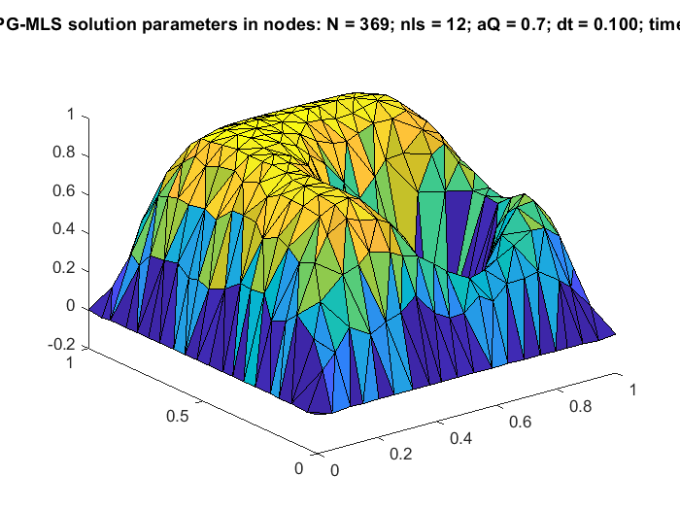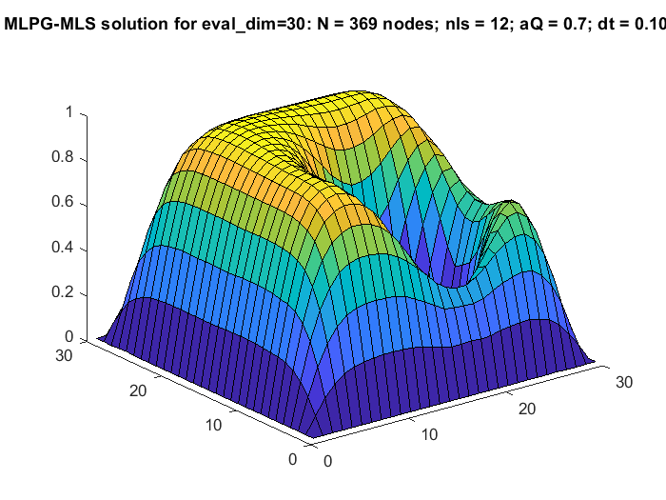
For the cases, where reference solution exists, as in the diffusion case, we get also error in nodes and evaluated error on the determined mesh:
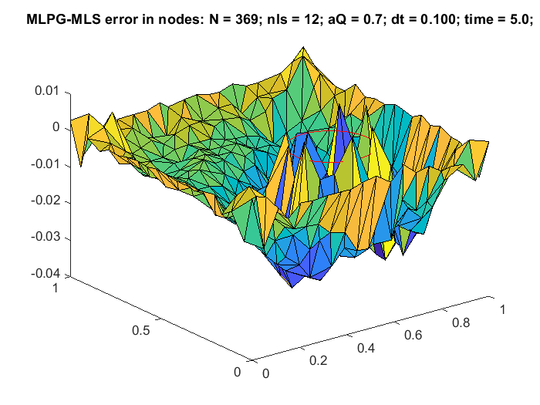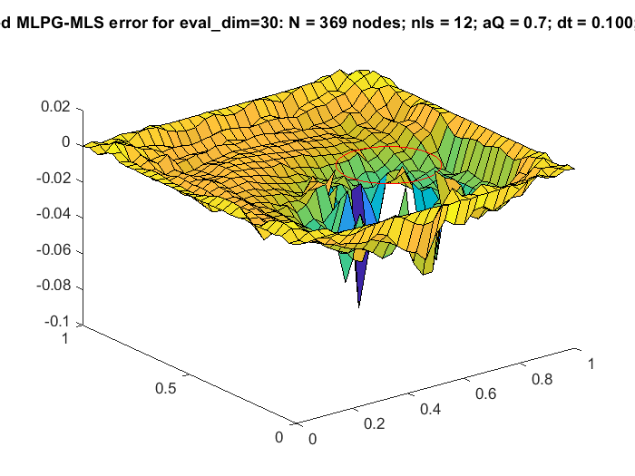
VII. All remaining parameters and results are written in file “avtoTestR.txt” in module 8, for example for the above case:
%method= 1 MLS-type= MLS , rHole= 0.000 , C= 1.000 , seriesLength= 50
%numNod seed irreg factor degre Iorder nI aInte aQuad eval_dim avgerr maxerr errL2 errH1 run_time exec_time
102400 17 0.200 1 2 5 12 2.780 0.700 20 0.79972755 2.01438477 0.16660709 NaN 10901.6830
%etime_in_seconds = 10901.698

Construction of system matrices
On the Matlab command window you should get the following output, which tells that the program run on a single processor, with 369 nodes. Construction of system matrices lasted 2.4 sec and system solution 0.05 sec.
>> MLPG_solution
##### All is done on P1 - kd-tree and ghost nodes are not needed #####

No_proc=1; No_nodes=369; nI=12; Time_kd_l1=0.006; time_P1_constr=2.399;
time_sol_bicgstab=0.049 after 50 timesteps.
etime_in_seconds =
6.5080
>>

If we change in the function the function \mfree\diffmfree.m

num_proc = 4;

we get one additional figure with decomposed domains and ghost nodes marked by green circles:
and the following output on the Matlab command window:
>> MLPG_solution
##### Splitting by X and then by Y: P1 finds LEFT and RIGHT halfs of kd-tree and ghost nodes and sends the RIGHT part and left ghost nodes to P2.
P1 and P2 find UP and DOWN halfs of these kd-trees for P3 and P4.#####

global_kd_x =
0.0052
global_kd_y =
0.0029
global_kd_y =
0.0037

No_proc=4; No_nodes = 369; nI=12; Time_gn_l1=0.312; Time_gn_l2=0.163;
No_P1_n=93; No_P1_gn=38; No_P2_n=92; No_P2_gn=41; No_P3_n=92; No_P3_gn=51; No_P4_n=92; No_P4_gn=42;
time_P1_constr=0.620; time_P2_constr=0.655; time_P3_constr=0.513; time_P4_constr=0.650;
time_sol_bicgstab=0.049 after 50 timesteps.
etime_in_seconds =
7.5590
>>

which tells that the program run on 4 processors, with 93 nodes on P1 and 92 nodes on P2, P3, P4, respectively, and maximum 51 ghost nodes. Construction of system matrices lasted 0.7 sec and system solution 0.05 sec. We can expect a significant speed-up of matrices construction time on four processors.

Measurements of linear system performances as a function of N
Because the processors have all necessary ghost nodes, an iterative parallel system construction is also possible.
intPX = [18,38,78,158,318]

No_proc=1; No_nodes=400; nI=12; Time_kd_l1=0.006; time_P1_constr=1.568;
time_sol_matlab=0.015
time_sol_matlab_LU=0.003
time_sol_bicg=0.009, flag=0, relres=4.425e-13, No_iter=237.0
time_sol_bicg_ilu=0.003, flag=0, relres=4.382e-14, No_iter= 15.0
time_sol_bicgstab=0.010, flag=0, relres=9.673e-13, No_iter=372.5
time_sol_bicgstab_ilu=0.010, flag=0, relres=8.247e-13, No_iter=372.5
time_sol_qmr=0.008, flag=0, relres=9.294e-13, No_iter=237.0
time_sol_cgs=0.006, flag=0, relres=7.963e-13, No_iter=157.0
time_sol_cgs_ilu=0.002, flag=0, relres=6.596e-13, No_iter=157.0
time_sol_Jacobi=0.037, flag=0, relres=9.963e-13, No_iter=537

No_proc=1; No_nodes=1600; nI=12; Time_kd_l1=0.009; time_P1_constr=7.616;
time_sol_matlab=0.014
time_sol_matlab_LU=0.024
time_sol_bicg=0.031, flag=0, relres=8.950e-13, No_iter=465.0
time_sol_bicg_ilu=0.006, flag=0, relres=6.809e-13, No_iter= 23.0
time_sol_bicgstab=0.058, flag=0, relres=3.208e-13, No_iter=920.5
time_sol_bicgstab_ilu=0.058, flag=0, relres=2.320e-13, No_iter=920.5
time_sol_qmr=0.034, flag=0, relres=6.827e-13, No_iter=464.0
time_sol_cgs=0.024, flag=3, relres=1.219e-12, No_iter=351.0
time_sol_cgs_ilu=0.004, flag=0, relres=5.038e-13, No_iter=351.0
time_sol_Jacobi=0.471, flag=0, relres=9.982e-13, No_iter=1968

No_proc=1; No_nodes=6400; nI=12; Time_kd_l1=0.035; time_P1_constr=48.166;
time_sol_matlab=0.053
time_sol_matlab_LU=0.267
time_sol_bicg=0.230, flag=0, relres=8.879e-13, No_iter=995.0
time_sol_bicg_ilu=0.041, flag=0, relres=3.728e-13, No_iter= 41.0
time_sol_bicgstab=0.694, flag=0, relres=3.137e-13, No_iter=2551.5
time_sol_bicgstab_ilu=0.694, flag=0, relres=6.066e-13, No_iter=2551.5
time_sol_qmr=0.248, flag=0, relres=8.627e-13, No_iter=987.0
time_sol_cgs=0.283, flag=3, relres=1.065e-06, No_iter=1073.0
time_sol_cgs_ilu=0.023, flag=0, relres=5.450e-13, No_iter=1073.0
time_sol_Jacobi=6.862, flag=0, relres=9.986e-13, No_iter=7272

No_proc=1; No_nodes=25600; nI=12; Time_kd_l1=0.134; time_P1_constr=488.441;
time_sol_matlab=0.274
time_sol_matlab_LU=3.353
time_sol_bicg=1.740, flag=0, relres=9.731e-13, No_iter=1851.0
time_sol_bicg_ilu=0.287, flag=0, relres=7.867e-13, No_iter= 71.0
time_sol_bicgstab=5.613, flag=0, relres=7.264e-13, No_iter=4265.5
time_sol_bicgstab_ilu=5.613, flag=0, relres=6.327e-13, No_iter=4265.5
time_sol_qmr=1.977, flag=0, relres=9.945e-13, No_iter=1870.0
time_sol_cgs=6.572, flag=1, relres=1.911e-05, No_iter= 79.0
time_sol_cgs_ilu=0.198, flag=0, relres=9.564e-13, No_iter= 79.0
time_sol_Jacobi=44.764, flag=1, relres=9.319e-09, No_iter=10001

No_proc=1; No_nodes=102400; nI=12; Time_kd_l1=0.575; time_P1_constr=9945.489;
time_sol_matlab=1.526
time_sol_matlab_LU=46.492
time_sol_bicg=16.274, flag=0, relres=9.551e-13, No_iter=3636.0
time_sol_bicg_ilu=2.133, flag=0, relres=2.437e-13, No_iter=138.0
time_sol_bicgstab=25.816, flag=1, relres=9.598e-08, No_iter=4695.0
time_sol_bicgstab_ilu=25.816, flag=0, relres=5.242e-13, No_iter=4695.0
time_sol_qmr=17.220, flag=0, relres=9.924e-13, No_iter=3662.0
time_sol_cgs=27.424, flag=1, relres=1.452e-05, No_iter= 84.0
time_sol_cgs_ilu=1.289, flag=0, relres=8.150e-13, No_iter= 84.0
time_sol_Jacobi=187.359, flag=1, relres=1.915e-07, No_iter=10001
etime_in_seconds =
1.0902e+04

Perspective methods only (on laptop):

>> MLPG_solution
intPX = [18,38,78,158,318,418,638]

No_proc=1; No_nodes=400; nI=12; Time_kd_l1=0.003; time_P1_constr=1.556;
time_sol_matlab=0.002
time_prec_bicg_ilu=0.000, time_sol_bicg_ilu=0.002, flag=0, relres=4.382e-14, No_iter= 15.0
time_prec_cgs_ilu=0.000, time_sol_cgs_ilu=0.001, flag=0, relres=6.596e-13, No_iter= 15.0
time_sol_Jacobi=0.021, flag=0, relres=9.963e-13, No_iter=537

No_proc=1; No_nodes=1600; nI=12; Time_kd_l1=0.010; time_P1_constr=7.789;
time_sol_matlab=0.011
time_prec_bicg_ilu=0.001, time_sol_bicg_ilu=0.006, flag=0, relres=6.809e-13, No_iter= 23.0
time_prec_cgs_ilu=0.001, time_sol_cgs_ilu=0.004, flag=0, relres=5.038e-13, No_iter= 23.0
time_sol_Jacobi=0.249, flag=0, relres=9.982e-13, No_iter=1968

No_proc=1; No_nodes=6400; nI=12; Time_kd_l1=0.033; time_P1_constr=48.425;
time_sol_matlab=0.055
time_prec_bicg_ilu=0.002, time_sol_bicg_ilu=0.047, flag=0, relres=3.728e-13, No_iter= 41.0
time_prec_cgs_ilu=0.003, time_sol_cgs_ilu=0.024, flag=0, relres=5.450e-13, No_iter= 41.0
time_sol_Jacobi=3.669, flag=0, relres=9.986e-13, No_iter=7272

No_proc=1; No_nodes=25600; nI=12; Time_kd_l1=0.133; time_P1_constr=622.068;
time_sol_matlab=0.278
time_prec_bicg_ilu=0.011, time_sol_bicg_ilu=0.279, flag=0, relres=7.867e-13, No_iter= 71.0
time_prec_cgs_ilu=0.011, time_sol_cgs_ilu=0.196, flag=0, relres=9.564e-13, No_iter= 71.0
time_sol_Jacobi=70.321, flag=0, relres=9.996e-13, No_iter=26948

No_proc=1; No_nodes=102400; nI=12; Time_kd_l1=0.539; time_P1_constr=10453.497;
time_sol_matlab=1.605
time_prec_bicg_ilu=0.041, time_sol_bicg_ilu=2.128, flag=0, relres=2.437e-13, No_iter=138.0
time_prec_cgs_ilu=0.042, time_sol_cgs_ilu=1.265, flag=0, relres=8.150e-13, No_iter=138.0
time_sol_Jacobi=1095.633, flag=0, relres=9.999e-13, No_iter=100833
etime_in_seconds =
1.1005e+04

No_proc=1; No_nodes=176400; nI=12; Time_kd_l1=0.896; time_P1_constr=32214.771;
time_sol_matlab=3.036
time_prec_bicg_ilu=0.069, time_sol_bicg_ilu=5.407, flag=0, relres=8.036e-13, No_iter=180.0
time_prec_cgs_ilu=0.077, time_sol_cgs_ilu=3.011, flag=0, relres=6.547e-13, No_iter=180.0
time_sol_Jacobi=4030.196, flag=0, relres=1.000e-12, No_iter=166207
etime_in_seconds =
3.6267e+04

No_proc=1; No_nodes=409600; nI=12; Time_kd_l1=2.264; time_P1_constr=167222.563;
time_sol_matlab=8.145
time_prec_bicg_ilu=0.174, time_sol_bicg_ilu=18.057, flag=0, relres=6.915e-13, No_iter=265.0
time_prec_cgs_ilu=0.170, time_sol_cgs_ilu=9.427, flag=0, relres=8.491e-13, No_iter=265.0
time_sol_Jacobi=20717.091, flag=0, relres=1.000e-12, No_iter=366917
etime_in_seconds =
1.8714e+05

Graphs are in excel file. No_iter should be NOT equal for bicg and cgs (there was an error in the Matlab code).

Other parameters from autoTest.txt:

%method= 1 MLS-type= MLS , rHole= 0.000 , C= 1.000 , seriesLength= 50
%numNod seed irreg factor degre Iorder nI aInte aQuad eval_dim avgerr maxerr errL2 errH1 run_time exec_time
409600 17 0.200 1

System solvers

We can use MAtLab solvers, e.g. \, BiCGstab, cgm, etc. The following external solvers are also implemented:
Jacobi (parallel version in the script: Jacobi_solve),
Gauss-Seidel (in the script: GS_SOR_solve),
Multi-grid (the following scripts are necessary: mgsolve, mgvcycle, mgiter and Common_functions: createmfreenodes, getavgnodaldistance, getsupdomain, findClosestNodes)
CG - to be implemented,...

Add Multigrid V-cycle in F-cycle.
Error MG-v in MG-f dosežeta enako napako na 5 decimalk, pričakovano, ker je bila toleranca 10^-6.
Multigrid F-cycle (IJS computer):

intPX = [18,38,78,158, 198] %in greater systems there a memory overflow error

No_proc=1; No_nodes=400; nI=11; Time_kd_l1=0.079; time_P1_constr=1.663;
time_sol_mg-f=1.193, flag=0, relres=3.053e-13, No_iter=5

No_proc=1; No_nodes=1600; nI=11; Time_kd_l1=0.023; time_P1_constr=6.967;
time_sol_mg-f=13.439, flag=0, relres=1.119e-13, No_iter=8

No_proc=1; No_nodes=6400; nI=11; Time_kd_l1=0.032; time_P1_constr=44.648;
time_sol_mg-f=168.467, flag=0, relres=1.731e-13, No_iter=9

No_proc=1; No_nodes=14400; nI=11; Time_kd_l1=0.063; time_P1_constr=154.614;
time_sol_mg-f=871.866, flag=0, relres=2.422e-13, No_iter=10

No_proc=1; No_nodes=25600; nI=11; Time_kd_l1=0.122; time_P1_constr=460.814;
time_sol_mg-f=2873.514, flag=0, relres=1.874e-13, No_iter=11

No_proc=1; No_nodes=40000; nI=11; Time_kd_l1=0.181; time_P1_constr=1239.718;
time_sol_mg-f=6917.744, flag=0, relres=3.184e-13, No_iter=9

Practically, in the same range as assembling. Maybe because of support domain search? Could be made faster?

